ePublisher Express And One-Click Publishing
ePublisher Express uses a One-Click Publishing workflow. This workflow gives content creators more time to spend on documentation by providing a streamlined and efficient publishing work flow which helps increases product value and customer loyalty. With the One-Click Publishing work flow, content creators can customize output by placing cues or markers in the source documents. We at WebWorks understand that this type of work flow sounds like it can be complicated as mediums change and documentation grows, but with ePublisher it can be simple and efficient in any environment. To accomplish this, we developed the unique concept of the ePublisher Stationery.
ePublisher Stationery is created in ePublisher Designer and then used by ePublisher Express in publishing jobs. ePublisher Stationery holds content styling information as well as instructions about the look and feel of the output. By creating and using Stationery to define and store publishing behavior, as content changes and grows, republishing new content with the same look and feel is as simple as a single click in ePublisher Express. Using the One-Click Publishing work flow, content creators know when it comes time to deliver, they can rely on the ePublisher Stationery to ensure that output generated will display properly for all audiences across all mediums. It does not matter how difficult the job, ePublisher can deliver to you – One-Click Publishing
To demonstrate the efficiency and ease of ePublisher One-Click Publishing work flow, when you requested and installed an ePublisher Express Trial, we supplied you with an ePublisher Express Project, pre-built ePublisher Stationery, and source documents . These can be found in the Documents area of your computer, in the folder "ePublisher Express Projects" and "ePublisher Stationery".
When you open the Express project for the first time, ePublisher will automatically load this Express project and you will follow the steps in the guide to load the source documents of your preferred format. This setup allows you to quickly and easily publish a HTML5 document set and PDF to learn more about our One-Click Publishing work flow. After you go through the ePublisher Trial Guide, if you would like a deeper understanding on how to customize ePublisher Stationery for your source documents, or multiple medium deliveries, visit the “Next Steps” window on the start page of your ePublisher Express Trial project.

About The Sample ePublisher Express Trial Source Documents
These Webworks sample source documents contain predetermined paragraph and character styles, marker types, conditions, variables, and cross-reference definitions that you can use to explore ePublisher capabilities and generate output. For example, the Webworks sample source documents contain sample paragraph styles, such as Heading 1, Heading 2, Title, and Body paragraph styles, and sample character styles, such as Bold and Emphasis, that are common in most source documents. These are not meant to show you all of ePublisher's capabilities, but to give you enough information to make an informed decision.
The sample source documents provided were created to be used in the following ways:
- You can follow the instructions in the ePublisher Express Trial Guide (located on the start page.) The ePublisher Express Trial guide will give you a good idea of how to use the ePublisher interface and it will explain the layout of our HTML5 document set. It then takes you through some tasks using the ePublisher system. During those tasks, you will use the instructions in this source document to edit the source before generating the HTML5 document set. Once generated, you will verify your work in the HTML5 document set then return to the guide for the next task.
- In the My Edits group, you can replace the existing content in the sample documents with some of your content, apply the provided paragraph and character styles and marker types available in the sample source documents to your content, and then generate and review output.
The instructions provided in the sample source documents to help you explore ePublisher assume that you already know how to work within your preferred authoring tool and file format. The documents give hints to help you along, but if at any point you feel you need a little more instruction, or if you have a question specific to your work flow just click on the “Contact Us” link in Next Steps.
The source documents are meant to give you live examples of the ePublisher work flow. How you would use the system on a day-to-day basis. If you find any errors in the document, try making edits and then generating a new correct HTML5 document set. That is the closest we can get you to a real-world example, so you can have enough information to make an informed decision.

About The Sample ePublisher Express Trial Stationery
This trial uses the ePublisher Express Trial Stationery. The ePublisher stationery is an electronic template that can be customized, in a purchased ePublisher seat, to your specific needs. It acts as your publishing assistant taking your style guide information and specific instructions, then executing to them every time it delivers content. Every ePublisher Express project is synchronized to stationery. ePublisher Express reads the content from the source documents, gets instructions from the synchronized stationery, and then publishes the output.
The stationery for these source documents was created with ePublisher Designer back in the WebWorks lab. ePublisher Designer is for building stationery with user styles, formatting information, and settings specific to your source documentation. ePublisher Designer also gives you the ability to set specific conditions that apply during the publishing process. The stationeries created by ePublisher Designer are portable, so they are usable with any Express project. Using the ePublisher work flow is how we are providing you with stationery already customized to the source documents supplied with this trial.
During this trial you will be using the pre-built stationery and source documents with an ePublisher Express project. After this trial if you feel ePublisher might be the right solution for you, go to the Next Steps section in ePublisher Express to schedule a demo for ePublisher Designer so we can show you how to customize a stationery to your documents.

Adding Functional Elements to Online Content Using ePublisher
When delivering your content through an online medium, there are many online features that you can take advantage of to increase the satisfaction of your user. For example, online features such as expand or collapse sections, related topics links, and mini Table of Contents (great for mobile outputs.) ePublisher makes it easy to incorporate these features into your output by simply marking sections of your source documents with the appropriate paragraph, character styles, marker types or output class. You do not need to write code for any of these features.
The following sections explain how to implement these features using the ePublisher system. You will use the proper paragraph or character styles, marker types or output class in the sample source documents to implement the following online features:
- Expand/Collapse
- Related Topics
- Context-Sensitive Help Topics
- Mini Table of Contents for Mobile Devices
Then in the “My Edits” section, you will see examples of how to incorporate different types of media assets using your authoring tools native insert ability, or by using conditional text. When installing ePublisher, we add a menu to give you the ability to use markers and conditional text. You will find these features in the WebWorks menu under the ADD-INS tab for Word.

Learning ePublisher Word Functions
Word is probably the most used authoring tool out there. This helps authors to create content right away because they are familiar with the tool. Unfortunately, Word still does not account for a lot of features needed to have a viable tool for single source multiple channel processing. Fortunately ePublisher enhances the features of Word with our ePublisher ADD-INS menu.

WebWorks Menu ADD-INS For Word
When you installed ePublisher, we placed an extended menu in the ADD-INS tab. This menu will give you the ability to add markers, context-sensitive help, and conditional text. Once you open the Word document, depending on your trust settings, you will have to enable macros to access the WebWorks menu.
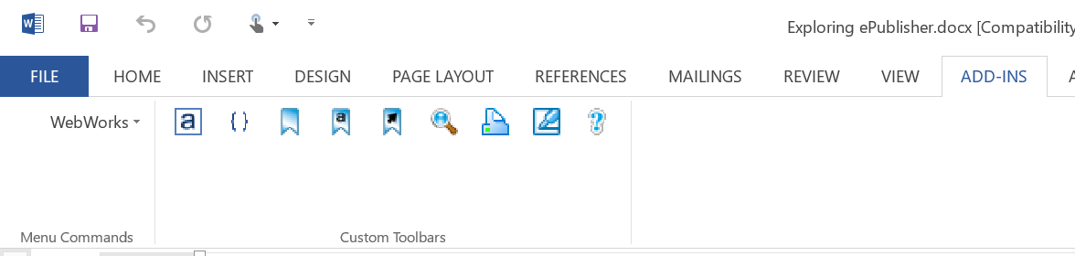

Enabling The WebWorks Menu With a Macro Warning
If you are working with the standard Word default settings, when you open up the Exploring ePublisher source documents, Word will display this warning (without the orange circle):
To get access to the WebWorks menu, simply click enable content

Enabling The WebWorks Menu Without a Macro Warning

If you do not have access to the WebWorks menu and you did not receive a warning, then you will need to check your Macro setting in the Trust Center Settings menu.
To access this menu, click on the tab in the top left corner. At the bottom of the file menu is the options tab, left click here:
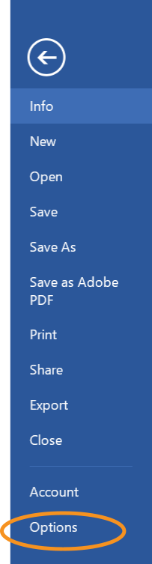
This will open a second window. The bottom of this menu is an option for the “Trust Center.” Selecting this option will show you the Trust Center window and a button labeled “Trust Center selections.” 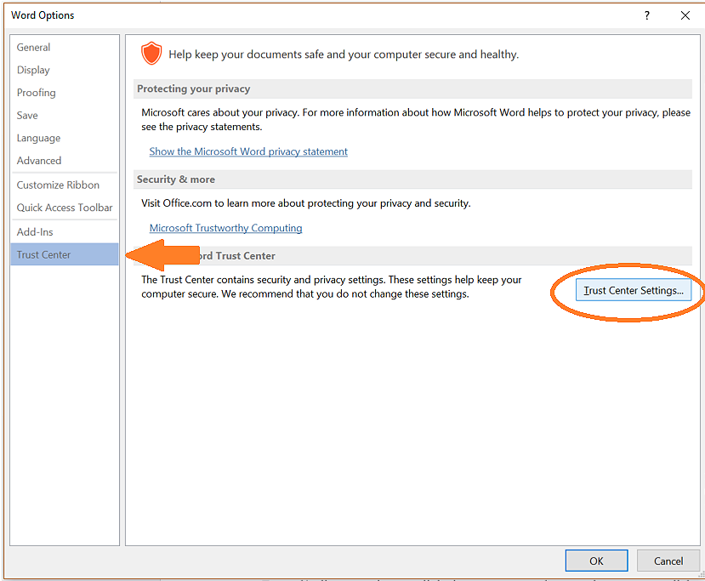

Left click on the button and then you will have some options to select from.
Here are your four options.
- Disable all macros without notification
- Disable all macros with notification
- Disable all macros except digitally signed macros
- Enable all macros (not recommended; potentially dangerous code can run)

By default Word has option two selected. With this option, when you open a word document with macros you will get the warning we previously discussed:
By clicking “Enable Content” this will give you access to the WebWorks menu.

If you did not get a warning, more than likely the first option was selected. To gain access, select option two and click OK. Close the Word Exploring ePublisher file, reopen and you should see the warning.
If you just want to enable macros without seeing any warnings, we would recommend option three. ePublisher is digitally signed to be recognized by Word. This is a safer option than number four which would provide no protection at all.

Expand/Collapse Sections
This section explains how you can mark " Expand/Collapse" sections in the source documents provided with the trial. The procedure will be the same when you purchase a full seat of ePublisher; the only difference will be that you get to customize which style name to mark the area.

Creating Expand/Collapse Sections
Expand/collapse sections are links in your generated output that users can click on to expand and collapse content. To create Expand/Collapse sections, you apply a paragraph style that has been defined with the Expand/Collapse feature in the ePublisher Stationery. By applying this defined style to a heading, the content creator has marked the beginning of the expand and collapse area. This is where ePublisher will place the trigger for the Expand/Collapse section. The content creator will then tag the end of the section with a marker.
In this example, the procedure list below has the “ExpandCollapse” paragraph style applied to the procedure title “To Create Expand/Collapse Sections” and a “DropDownEnd” marker is inserted at the end of procedure three.
If you do not see the marker, make sure you have gone to the WebWorks Add-INS menu and have clicked “Show Hidden Text and Fields.”
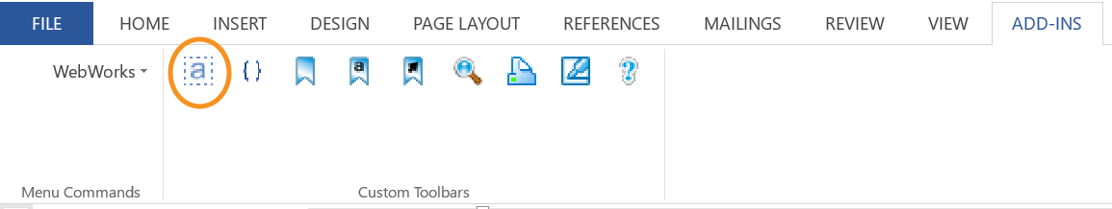

In the ePublisher Stationery, the paragraph style “ExpandCollapse” was defined with the Expand/Collapse feature. As a result, the procedure title displays a trigger next to it in the generated output. When users click the trigger, the steps in the procedure will display.
Click the arrow to display the steps in the procedure below.
Creating Expand/Collapse Sections
- Create content that will serve as the link users click to expand or collapse the content.
- Apply the Expand/Collapse paragraph style to the content.
- Insert a DropDownEnd marker at the end of the content you want to include in the expand/collapse section.

Creating Your First Expand/Collapse Section
The previous section explains how you can create expand and collapse sections by applying an Expand/Collapse paragraph style. In this section, you will create an expand/collapse section using the ePublisher Express Trial source documents and stationery. If you have not already read the section on how to activate the WebWorks add-ins menu, click here.
Creating Your First Expand/Collapse Section
- In the Document Manager window, look for the Word document Exploring ePublisher.doc
- Double click on the Word document Exploring ePublisher to open the file in Word
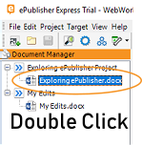
- Find the section “Creating Your First Expand/Collaspe Section”
- In the section “Creating Your First Expand/Collaspe” place your curser on the procedure title “To Create Your First Expand/Collapse Section.
- Change the paragraph style from “ProcedureTitle” to “ExpandCollapse” in title statement above.
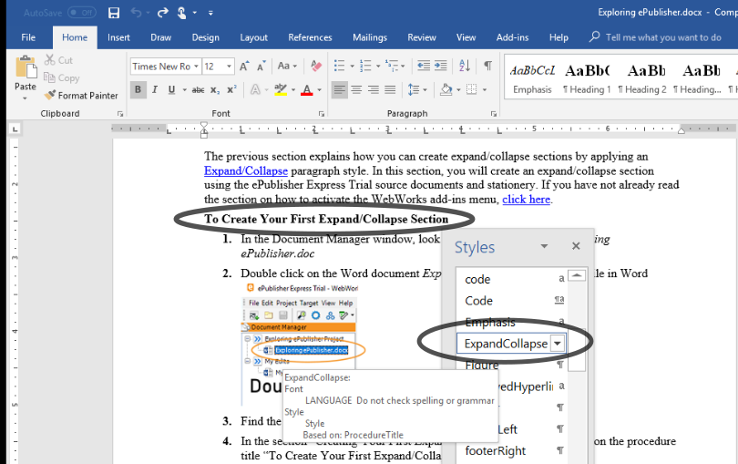
- Insert a “DropDownEnd” marker after the last sentence in this procedure. Do not specify any text in the Marker Text field when you insert the marker.

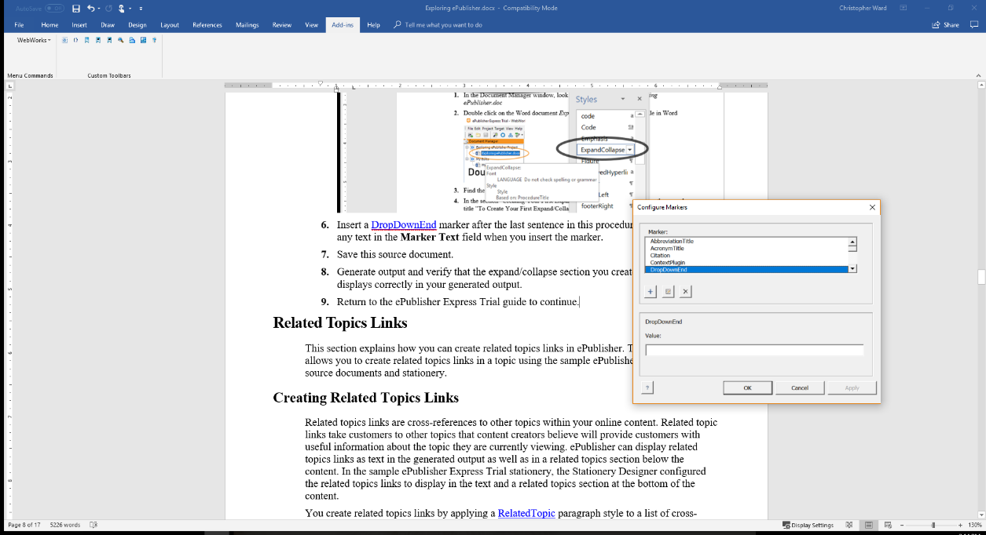
- Save this source document.
- Generate output and verify that the expand/collapse section you created in this section displays correctly in your generated output.
- Return to the ePublisher Express Trial guide to continue.

Related Topics Links
Related topic links are a good way to help your user find more relevant information and improve their experience. This section shows how to create related topics links using the ePublisher work flow. As in the previous section, you will read how to create Related Topic links, make changes to the source documents via the instructions provided, and then generate output to verify the changes were made correctly.

Creating Related Topics Links
Related topics links are cross-references to other topics within your online content. Related topic links take users to other topics that content creators believe will provide them with useful information about the topic they are currently viewing. ePublisher can display related topics links as text in the generated output as well as in a related topics section below the content. In the sample ePublisher Express Trial, the stationery was configured to display the related topics links in a section at the bottom of the content.
Related topics links are created by applying a RelatedTopic paragraph style to a list of cross-references in your source documents. When you generated output, the list of cross-references will automatically display as related topic links at the bottom of the page.
Creating Related Topics Links
- In your source document, find the topic for which you want to create a Related Topics section.
- Create a list of cross-references for the topics you want to display in the Related Topics section at the bottom of the page.
- Apply the RelatedTopics paragraph style to the list of cross-references.

Expand/Collapse
Related Topics
In generated output, a related topics section displays at the bottom of this topic. If you are reading this in the output, you can see the related topics section at the bottom. Go ahead and click the links, they work.

Creating Your First Related Topics Link
The previous section explains how you can create related topics lists by inserting a list of cross-references into a topic and then applying a Related Topic paragraph style. In this section, you will create your first related topics section using the ePublisher Express Trial source documents and stationery.
Creating Your First Related Topics Link
- In the Document Manager window, look for the Word document Exploring ePublisher.doc
- Double click on the Word document Exploring ePublisher to open the file in Word
- Find the section “Creating Your First Related Topics Links”
- Apply the RelatedTopic paragraph style to the list of cross-references inserted at the end of the section.
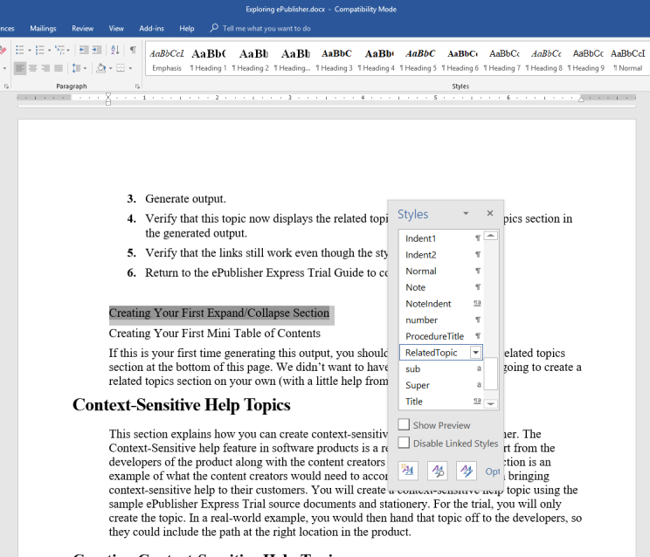
- Save this source document.
- Generate output.
- Verify the Related Topics section was generated by navigating to the section “Creating Your First Related Topics Links” in the new HTML5 document set.
- Return to the ePublisher Express Trial guide to continue.

Creating Your First Expand/Collapse Section
Creating Your First Mini Table of Contents
If this is your first time generating this output, you should notice that there is no related topics section at the bottom of this page. We didn’t want to have all the fun, so you are going to create a related topics section on your own (with a little help from our instructions)

Context-Sensitive Help Topics
This section explains how you can create context-sensitive help topics in ePublisher. The Context-Sensitive help feature in software products is a result of a combined effort from the developers of the product along with the content creators for the product. This section is an example of what the content creators would need to accomplish to do their part in bringing context-sensitive help to their users. You will create a context-sensitive help topic using the sample ePublisher Express Trial source documents and stationery. For the trial, you will only create the topic. In a real-world example, you would then hand that topic off to the developers, so they could include the path at the right location in the product.

Creating Context-Sensitive Help Topics
Context-sensitive help topics provide users with immediate assistance without requiring them to leave the context in which they are working. They help answer questions like "What is this?" and "Why would I use this?", by providing information for a particular object in the proper context. Many applications support context-sensitive help by allowing a user to click on a Help button on an application window. When the user clicks on the Help button, a context-sensitive help topic, related to the application, will display.
For example, within an application, you might see the following window.
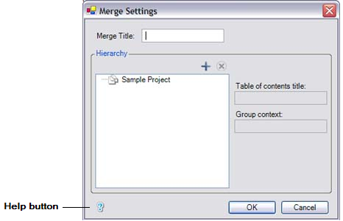

If the user clicks on the Help button, then the context-sensitive help topic associated with the window displays.
ePublisher allows you to create context-sensitive help topics through the use of TopicAlias markers and specific Universal Resource Locator (URL). The content creator inserts a TopicAlias marker in each context-sensitive help topic they create. With TopicAlias markers, ePublisher can create a specific URL address to make it easier to manage Context-sensitive help. Applications use the specific URL to determine which topic to display when users click on the Help button on an application window.
In this source document, the first paragraph in this topic has a TopicAlias marker inserted in front of it. The topic ID specified in the TopicAlias marker is
IDH_CreatingContextSensitiveHelpTopics.
The Stationery Designer assigned the appropriate context-sensitive behavior to the TopicAlias marker type in the sample ePublisher Express Trial stationery. You can see this TopicAlias marker through the reporting feature of ePublisher. Every time you have ePublisher generate output, it creates reports, so you can easily manage aspects of your publishing work flow. If you take a look at the reports window (scroll down to the bottom of the Output Explorer window) You can see, we give you two types of reports:
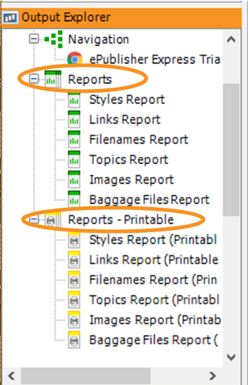

The first section (in green) is for in-product reporting. Clicking these links will display the output in the log window, and give you access to helpful links. The second section (in yellow) is the same report with the same information. It is just formatted in HTML to make the information print friendly. It will contain the same helpful links.
To view the TopicAlias marker, use the “Topics Report” in the printable section.
Clicking on the Topics Report will open a new browser window. The description section lists the actual Topic ID. Developers use the path ePublisher creates, NOT the Topic ID, to trigger the help topic when a user would click on a “?” or some other icon your company has chosen to represent help guides. You can experience that functionality by clicking on the word “Output” under the “Links” section in the report. Clicking will trigger the page of the path.
ePublisher list all paths in a single file that you can hand over to your developers. Located in the same area as the reports, this file is located more to the top of the list of files. The name of the file is always the same. If you would like to see the paths ePublisher created, open the file “url_maps.xml”. The following steps go over how to create and place TopicAlias markers.
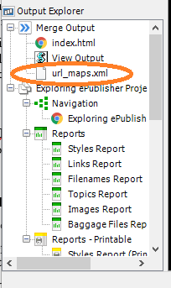

Using ePublisher to generate your TopicAlias markers is the simplest way to manage context-sensitive help in your product. As long as the name of the marker never changes, the path generated by ePublisher will never change, giving you peace of mind when it comes to your context-sensitive help.
Creating a Context-Sensitive Help Topic
- Locate your context-sensitive help topic.
- Insert your cursor into the topic. For example, you can insert your cursor at the beginning of a topic heading or in front of the first word in the first paragraph of a topic.
- Insert the TopicAlias marker.
- In the Marker Text field, type in the topic ID you want to specify for the context-sensitive help topic.
For example, in this topic, a TopicAlias marker is inserted in front of the first paragraph in the topic. The topic ID specified in the TopicAlias marker is IDH_CreatingContextSensitiveHelpTopics.

Creating Your First Context-Sensitive Help Topic
The previous section explains how you can create context-sensitive help topic by inserting a TopicAlias marker and specifying a topic ID as the marker text. In this section, you will create your first context-sensitive help topic using the ePublisher Express Trial source documents and stationery. If you do not see the marker, make sure you have gone to the WebWorks Add-INS menu and have clicked “Show Hidden Text and Fields.”

Creating Your First Context-Sensitive Help Topic
- In the Document Manager window, look for the Word document Exploring ePublisher.doc
- Double click on the Word document Exploring ePublisher to open the file in Word
- Find the section “Creating Your First Context-Sensitive Help Topic”
- Insert a TopicAlias marker in front of the first paragraph in the section “Creating Your First Context-Sensitive Help Topic.”
- Specify IDH_CreatingYourFirstContextSensitiveHelpTopic as the topic ID for the topic by typing this text in the Value field for the marker.
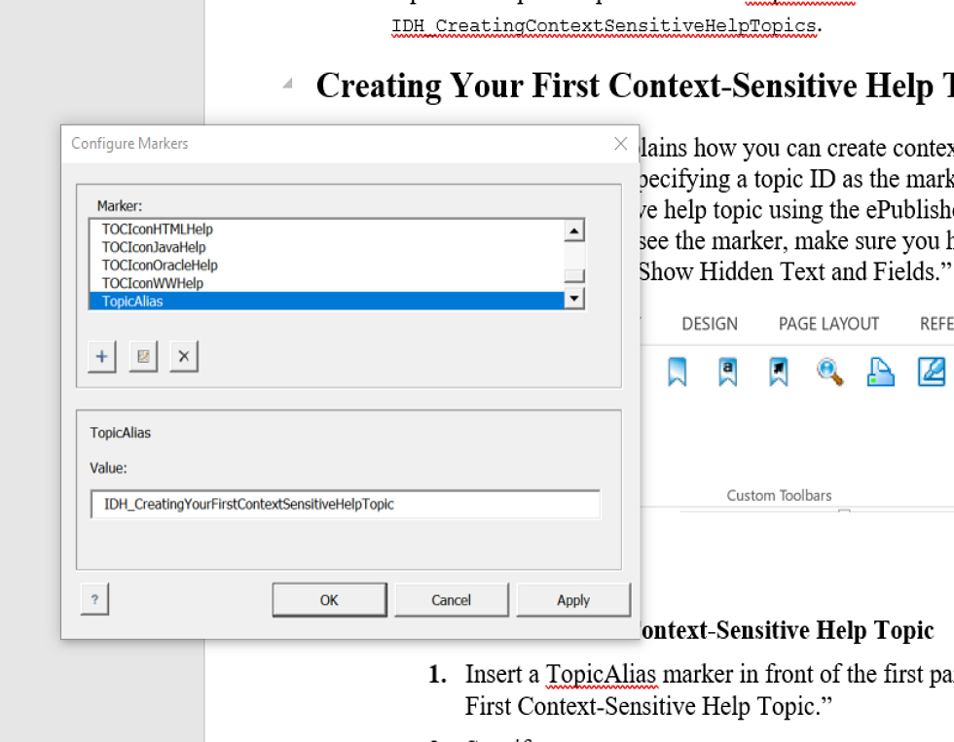
- Save this source document.
- Verify that this topic marker now displays the Topics Report by launching the report from the Output Explore in the ePublisher Express Project.
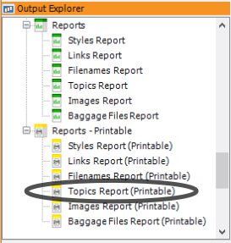
- Verify that the link works by clicking “Output” in the Topics Report.
- Return to the ePublisher Express Trial Guide to continue.

Mini Table of Contents
WebWorks dedicates time and resources to understanding technologies and devices that content is created on and delivered too. As we come to understand these elements, we develop features in our product to help our users take advantage of the new technology. You will find that ePublisher can add rich HTML features to your output by simply assigning the proper style name to the proper section. One of these features is Mini Table of Contents

Creating a Mini Table of Contents
A Mini Table of Contents appears underneath a title. It is an area that lists the subheading in the section and provides a link to each. These are great for outputs without traditional Table of Contents and idea for smaller screens.
Creating a Mini Table of Contents
- Locate your topic title.
- Apply the unique style you have determine will represent titles with mini Table of Contents. This unique name will have the “mini TOC” feature associated with it in the stationery.
- Save the document
- Use ePublisher to generate output.
- Locate the section in the output to verify the mini Table of Contents.

Creating Your First Mini Table of Contents
In this example, you are going to add the style “Title w_Mini TOC” to the title of this section “Mini Table of Contents for Mobile Devices.” Adding this style will add a mini Table of Contents underneath this title in the generated output. The mini Table of Contents is a good way for a content creator to increase the navigation features of their output for a mobile audience, or a quick way to jump to sections within a topic.
Creating Your First Mini Table of Contents
- In the Document Manager window, look for the Word document Exploring ePublisher.doc
- Double click on the Word document Exploring ePublisher to open the file in Word
- Find the section “Mini Table of Contents for Mobile Devices”
- Highlight the Title for the section “Mini Table of Contents for Mobile Devices”
- Apply the paragraph style “Title w_Mini TOC.”
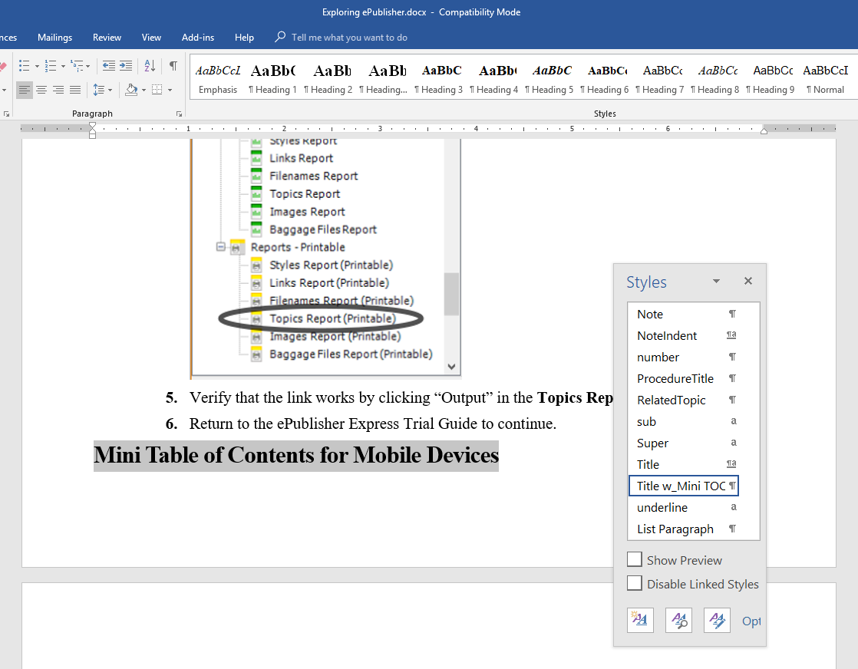
- Save this source document
- Generate output using ePublisher Express Trial project.
- Navigate to the section “Mini Table of Contents for Mobile Devices” in the generated output and verify the mini Table of Contents.
- Return to the ePublisher Express Trial Guide to continue.
Yep, it is that easy. This feature was enabled in the stationery using ePublisher Designer. The styling information of Title and Title w_Mini TOC are the same, so the output looks uninformed. The only difference is that under the latter, ePublisher sees the command to generate a mini Table of Contents after this topic. This gives the content creator the ability to place a mini Table of Contents on any title they choose, simply by labeling it with the correct paragraph style name.

Word Styles Quick Reference
Word styles are a collection of attributes and formatting information that can be used to ensure uniformity throughout source document and generated output. The following sections provide definitions for the styles used within this source document. Use the information in this section to learn more about the different paragraph and character styles and marker types used within this source document.

Paragraph Styles
Paragraph styles apply to entire paragraphs of text. Use paragraph styles if you want to apply certain formatting to a particular section of your content.
Body
All content that serves as the body of this document uses the Body paragraph style. For example, any text that is not part of a table, numbered or bulleted list should use the Body paragraph style
Bullet, Bullet2
The Bullet styles allow you to create unordered lists. The Bullet styles provide you with a level of indentation that matches exactly with your Body paragraph style. The Bullet2 style provides you with one level of indentation from the Body paragraph style.
Chapter Title
The Chapter Title paragraph style allows you to identify new chapters in your document. This style uses autonumbering to append chapter numbers to your headings.
ExpandCollapse
The ExpandCollapse style creates links that display or hide content in an expand/ collapse section in the generated output. Apply this style to any text that you want to serve as a link for an expand/collapse section.
GlossDef
The GlossDef style should be applied to the glossary definition for glossary terms.
GlossTerm
The GlossTerm style should be applied to any glossary term that will appear in the glossary section. Content with the GlossTerm style should always precede the GlossDef style.
Heading1, Heading 2 and Heading 3
Heading styles can be used to label titles for major sections in source documents. Each heading style differs in font size and font weight.
Indent1, Indent2
The Indent styles should be used when you want to apply a greater level of indentation to your Body style. Use Indent1 if you want to indent your content one level in from the Body style. Use Indent2 if you want to indent your content two levels in from the Body style.
Number, Number1
The Number styles allow you to create ordered lists. The first item in your list should use the Number1 style, and the content following the first item should use the Number style.
ProcedureTitle
The ProcedureTitle style should be used for procedure introductory statements. Apply this style to any text that introduces the procedure. This style does not create expand/ collapse sections that display or hide steps in a procedure. If you want to create procedure introductory statements that display or hide steps in a procedure, use the ExpandCollapse paragraph style.
RelatedTopic
The RelatedTopic style creates related topics links in the generated output. Apply this style to a list of cross-references that you want to display as links in your generated output.

Character Styles
Character styles allow you to override paragraph styles when you need to change the style attributes for a small amount of text. For example, you can use character styles when you want to italicize or underline a specific word in a paragraph without overriding the existing paragraph style.
Bold
The Bold style allows you to stress certain words or phrases throughout your content.
Code
The Code style allows you to apply a monospace font to text that will appear as code in your content.
Emphasis
The Emphasis style allows you to italicize certain words or phrases throughout your content.
Hyperlink
The Hyperlink style applies a blue font and underline to text, which allows you to display URL addresses and other links as clickable items.
Sub
The Sub style allows you to apply a subscript font to text. Any text with the Sub style applied displays below the baseline of the normal text.
Super
The Super style allows you to apply a superscript font to text. Any text with the Super style applied displays above the baseline of the normal text.
Underline
The Underline style allows you to add an underline underneath the text.

Marker Types
Marker types allow you to embed information in your source documents and add functional elements to your generated output. For example, you can use markers to create popup windows and context-sensitive help topics.
DropDownEnd
The DropdownEnd marker should be inserted at the end of the text that you want to display in an expand/collapse section. This marker indicates the end of the content you want to display in an expand/collapse section.
Filename
The Filename marker should be inserted if you want to specify output filenames when ePublisher generated output. Specify the desired name for the file as the marker text for the marker.
TopicAlias
The TopicAlias marker should be inserted in any topic that you want to use as a context-sensitive help topic. Specify the topic ID you wish to assign to the topic as the marker text for the marker.

Search Relevance Example
This next section is so we can show an example of the Relevance Ranking search feature in Reverb 2.0. The ePublisher Express Trial guild talks about this feature and others. We walk you through all the features in the Search Showcase section of the guide. So, you can ignore the next couple of sections and move on down to Creating Your Own Content and Using Media Assets.

This Paragraph Has Brown Several Times And Should be on Top
This paragraph should be on top of the search result, but it is not. The word brown appears in here several times. When you search for brown it appears 2nd on the search results. The quick brown fox jumps over the lazy dog. The quick brown fox jumps over the lazy dog. The quick brown fox jumps over the lazy dog. The quick brown fox jumps over the lazy dog. The quick brown fox jumps over the lazy dog. The quick brown fox jumps over the lazy dog. The quick brown fox jumps over the lazy dog. The quick brown fox jumps over the lazy dog. The quick brown fox jumps over the lazy dog. The quick brown fox jumps over the lazy dog. The quick brown fox jumps over the lazy dog. The quick brown fox jumps over the lazy dog. The quick brown fox jumps over the lazy dog. The quick brown fox jumps over the lazy dog. The quick brown fox jumps over the lazy dog. The quick brown fox jumps over the lazy dog.
The quick brown fox jumps over the lazy dog. The quick brown fox jumps over the lazy dog. The quick brown fox jumps over the lazy dog. The quick brown fox jumps over the lazy dog. The quick brown fox jumps over the lazy dog. The quick brown fox jumps over the lazy dog. The quick brown fox jumps over the lazy dog. The quick brown fox jumps over the lazy dog.

This Paragraph Has Brown a Few Times And is on Top
This paragraph has a higher relevance attached to it through ePublisher and this is why it is on top. Video provides a powerful way to help you deliver a message or show the steps in a procedure. When you click Online Video, you can paste the embed code for the video you want to add. You can also type a keyword to search online for the video that best fits your document. To make your document look professionally produced, Word provides header, footer, cover page, and text box designs that complement each other. For example, you can add a matching cover page, header, and sidebar. Click Insert and then choose the elements you want from the different galleries. Themes and styles also help keep your document coordinated.
When you click Design and choose a new Theme, the pictures, charts, and SmartArt graphics change to match your new theme. When you apply styles, your headings change to match the new theme. Save time in Word with new buttons that show up where you need them. To change the way a picture fits in your document, click it and a button for layout options appears next to it. When you work on a table, click where you want to add a row or a column, and then click the plus sign. Reading is easier, too, in the new Reading view. You can collapse parts of the document and focus on the text you want.

Creating Your Own Content And Using Media Assets
The previous sections showed you just a sample of the power of ePublisher. We wanted to give you an area where you could use your content and possibly some of your media assets. This area is in the document located in the "My Edits" section of the Document Manager window in ePublisher Express. If you have enjoyed your experience with ePublisher and would like to learn more, check out the “Next Steps” section located in your ePublisher Express Trial.

You can also contact us at 877-6-WEBWORKS or (877) 693-2967. Our sales department can answer any questions or move you on to customizing an ePublisher project with your documentation.

